Project - High Level Design
on
Multimodal Insurance Creator

Course Name: Gen AI

Institution Name: Medicaps University – Datagami Skill Based Course

Student Name(s) & Enrolment Number(s):
Sr no | Student Name | Enrolment Number
01 | Ananya Madanala | EN22CS301119
02 | Anind Bilthariya | EN22CS301129
03 | Arpita Solanki | EN22CS301202
04 | Ashutosh Singh | EN22CS301221
05 | Avani Sharma | EN22CS301240

Group Name: 08D2
Project Number: GAI-20
Industry Mentor Name: Mr. Rishab Tripathi
University Mentor Name: Dr. Hemlata Patel
Academic Year: 2025-2026

Table of Contents
- Introduction.
  - Scope of the document.
  - Intended Audience
  - System overview.
- System Design.
  - Application Design
  - Process Flow.
  - Information Flow.
  - Components Design
  - Key Design Considerations
  - API Catalogue.
- Data Design.
  - Data Model
  - Data Access Mechanism

- Interfaces
5. Non-Functional Requirements
4.1 Security Aspects
4.2 Performance Aspects
6. References

1. Introduction:-

1.1 Scope of the Document
This document describes the high-level design of the Multimodal Insurance Creator System, a Generative AI-based application that integrates Large Language Models (LLMs), a Vector Database, and Text-to-Image models to generate structured insurance insights along with visual infographic representations.
The document outlines system architecture, component design, process flow, APIs used, interfaces, and non-functional requirements.

1.2 Intended Audience
This document is intended for the following stakeholders:

- Academic evaluators
- Project reviewers
- Developers
- System architects
It provides both technical and architectural understanding of the system.

1.3 System Overview
The Multimodal Insurance Creator is an AI-powered system that:
- Accepts insurance-related user queries
- Retrieves relevant information from an insurance knowledge base (PDF)
- Generates structured insurance explanations using an LLM
- Produces a corresponding visual infographic using a text-to-image model

The system demonstrates:
- Context-aware response generation
- Text and Visual content creation

2.System Design:

2.1 Application Design
The system follows a modular AI-driven architecture consisting of:
- User Interaction Layer
- Knowledge Retrieval Layer
- Language Model Processing Layer
- Image Generation Layer
- Output Rendering Layer

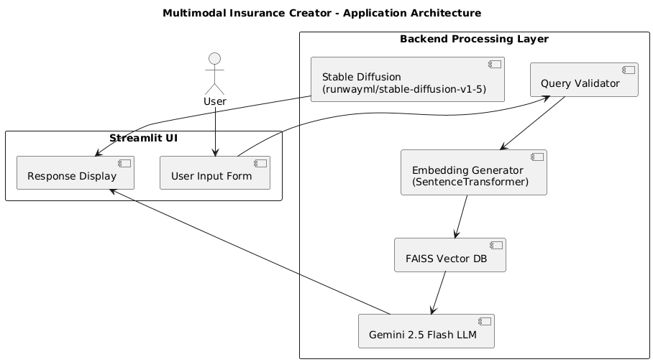

2.2 Process Flow

The step-by-step process is:
- User inputs an insurance-related query.
- System validates whether the query is insurance-related.
- The query is converted into embeddings using Sentence Transformers.
- FAISS vector database retrieves top relevant document chunks.
- Retrieved context is passed to Gemini 2.5 Flash.
- Gemini generates structured insurance analysis.
- A visual prompt is generated.
- Stable Diffusion (runwayml) generates an infographic image.
- Text response and infographic are displayed.

2.3 Information flow

User Query
↓
Query Validation
↓
Embedding Generation
↓
FAISS Similarity Search
↓
Context Retrieval
↓
Gemini LLM Processing
↓
Structured Insurance Output
↓
Text-to-Image Model
↓
Infographic Output

2.4 Components Design

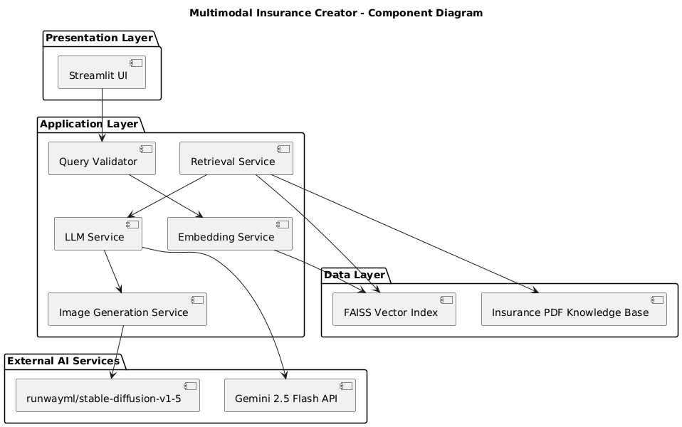

The system follows a layered architecture consisting of four primary layers:

1. Presentation Layer
Component: Streamlit UI
This is the user-facing interface built using Streamlit.
It is responsible for:
- Accepting natural language insurance queries
- Triggering backend processing
- Displaying structured text responses
- Rendering generated infographic images
The UI acts as the entry and exit point of the system.

2. Application Layer
This layer contains the core business logic and processing modules.

a) Query Validator
- Ensures that the user query is related to insurance.
- Prevents irrelevant or malicious inputs.
- Acts as the first filtering mechanism.

b) Embedding Service
- Converts user query into vector embeddings using SentenceTransformer.
- Enables semantic search capability.

c) Retrieval Service
- Interacts with the FAISS Vector Index.
- Retrieves top relevant document chunks from the Insurance PDF knowledge base.
- Provides contextual information to the LLM.

d) LLM Service
- Sends the retrieved context and user query to Gemini 2.5 Flash API.
- Generates structured insurance insights such as:
  - Risk distribution
  - Cost breakdown
  - Coverage analysis
  - Prevention measures
- Also prepares a visual prompt for image generation.

e) Image Generation Service
- Uses runwayml/stable-diffusion-v1-5 model.
- Converts visual prompt into infographic-style image.
- Returns generated image to the UI.

3. Data Layer

a) Insurance PDF Knowledge Base
- Contains domain-specific insurance content (44-page document).
- Text is chunked for embedding and retrieval.

b) FAISS Vector Index

- Stores document embeddings.
- Performs fast similarity search.
- Enables Retrieval-Augmented Generation (RAG).
This layer ensures contextual grounding of LLM responses.

4. External AI Services

a) Gemini 2.5 Flash API
- Provides large language model capabilities.
- Generates structured, context-aware insurance explanations.

b) runwayml/stable-diffusion-v1-5
- Generates visual infographic outputs.
- Enables multimodal capability of the system.

2.5 Key Design Considerations

• Context-Aware Generation
- Retrieval-Augmented Generation improves factual consistency.
• Modularity
- Easy to replace image model if needed.
• Scalability
- FAISS allows scalable semantic search.
- Larger knowledge bases can be integrated.
• Fault Tolerance
- Non-insurance queries are filtered.
- Image generation failures handled.

2.6 API Catalogue
API / Model | Purpose
Gemini 2.5 Flash | Text generation
SentenceTransformer (all-MiniLM-L6-v2) | Embedding generation
FAISS | Vector similarity search
Stable Diffusion(runwayml) | Image generation
PyPDF | PDF text extraction

3. Data Design

1. Knowledge Base Data
- Source: Insurance PDF
- Format: Unstructured text
- Processing:
  - Text extraction
  - Chunking into segments
- Each chunk becomes a retrievable unit

2. Embedding Model
Each text chunk is converted into:
- High-dimensional numerical vector
- Generated using SentenceTransformer

3. FAISS Index Model
- Stores embedding vectors
- Enables similarity search
- Maps vector → corresponding text chunk

3.2 Data Access Mechanism

The system uses semantic search rather than SQL-based querying.

Data Access Flow:
- User query → converted to embedding
- FAISS performs similarity search
- Top-K similar chunks retrieved
- Retrieved context passed to Gemini LLM
Data access type:
- Read-heavy
- No update/delete operations during runtime
All access is performed through Python function calls within the application.

4. Interfaces
This section describes the interfaces between different system components including the User Interface, LLM services, and Image Generation services.

4.1 User Interface

The system provides a web-based user interface built using Streamlit.

4.2 External AI APIs
- Gemini API for text generation
- HuggingFace model repository (for diffusion models)

4.3 Internal Interfaces
- Embedding model → FAISS
- FAISS → LLM
- LLM → Image Prompt
- Image Model → Matplotlib renderer

5. Non-Functional Requirements
Non-functional requirements define the quality attributes of the system.

5.1 Security Aspects
- No sensitive user data is stored.
- No external database persistence.
- Gemini API calls are made over HTTPS.

5.2 Performance Aspects
- Embedding generation optimized using MiniLM model.
- FAISS enables fast vector similarity search (O(log n)).
- System response time: 5–15 seconds per query (GPU enabled).

6. References
• Google Gemini API Documentation
https://ai.google.dev
• FAISS Library Documentation
https://faiss.ai
• Sentence Transformers
https://www.sbert.net
• Stable Diffusion Model Card
https://huggingface.co/stabilityai

